Portable process calibrator
approved for hazardous areas

Klingenberg, July 2019
WIKA's CPH7000 portable process calibrator has received ATEX approval. It is therefore also suitable for use in hazardous areas.

The CPH7000 provides highly flexible on-site calibration for process transmitters and pressure gauges. A high-pressure version even tests measuring ranges up to 10,000 bar. The portable, multi-function instrument integrates an electronics module, a hand pump for generating test pressures of up to 25 bar and a high-performance data logger. Due to its equipment, the CPH7000 also fulfils test tasks for the measurement parameters of temperature, voltage and current.

Number of characters: 607
Key word: CPH7000 with ATEX

Manufacturer:
WIKA Alexander Wiegand SE & Co. KG
Alexander-Wiegand-Straße 30
63911 Klingenberg/Germany
Tel. +49 9372 132-5049
Fax +49 9372 132-406
vertrieb@wika.com
www.wika.de

WIKA company photograph:
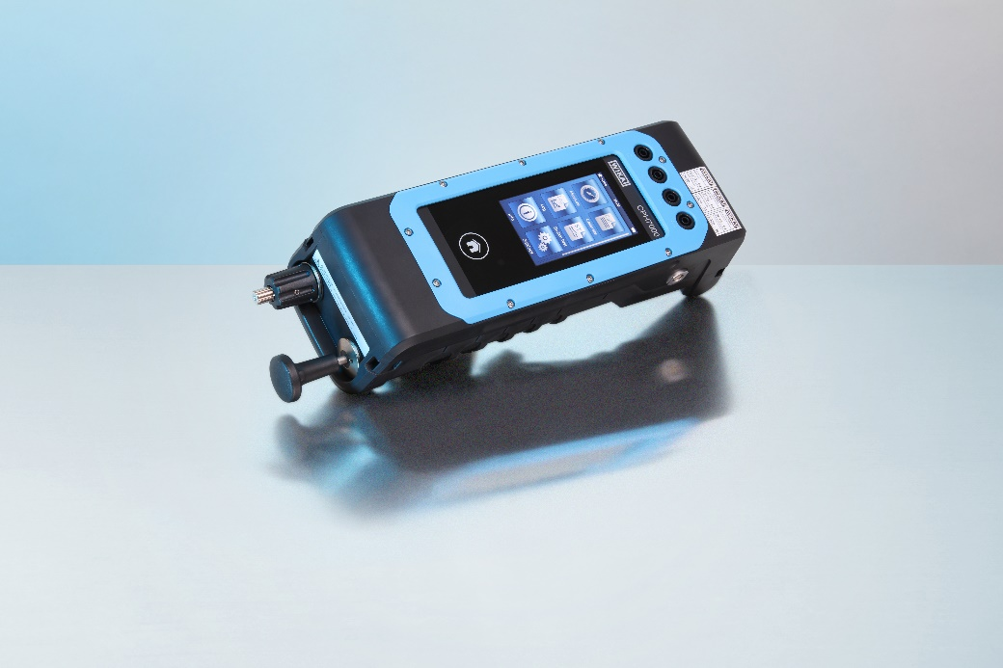
CPH7000 with ATEX approval

Edited by:
WIKA Alexander Wiegand SE & Co. KG
André Habel Nunes
Marketing Services
Alexander-Wiegand-Straße 30
63911 Klingenberg/Germany
Tel. +49 9372 132-8010
Fax +49 9372 132-8008010
andre.habel-nunes@wika.com
www.wika.de

WIKA press release 08/2019

