EMICOgauge pressure measuring system
protects people and the environment

Klingenberg, January 2022. The new Emission Control Gauge (EMICOgauge) pressure measuring system from WIKA ensures safety for people and the environment in critical processes. It features the assembly of a model 2xx.30 pressure gauge in a safety version in accordance with EN 837-1 (S3) and a valve to prevent fugitive emissions.

An easily rotating adapter with a special sealing packing connects the measuring instrument and the valve. The system is fully leak-tested in accordance with the requirements of TA Luft (VDI 2440) for fugitive emissions. The EMICOgauge measures pressures from 0 to 420 bar or 6,000 psi. In the event of a fault due to high overpressure, the S-3 safety version protects the user from injury.

The compact measuring system can be put into operation immediately after delivery. The freely rotating swivel adapter allows 360° positioning of the display and easy dismounting of the measuring instrument, for example, for calibration. The S-3 pressure gauges can be combined with the following valves in fugitive emission design, in accordance with ISO 15848-1 and TA-Luft, to form EMICOgauges: Model IVM monoflange as well as models IV1x and IV2x (block & bleed) needle valves.

Number of characters: 1.172
Key word: EMICOgauge

Manufacturer:
WIKA Alexander Wiegand SE & Co. KG
Alexander-Wiegand-Straße 30
63911 Klingenberg/Germany
Tel. +49 9372 132-0
Fax +49 9372 132-406
vertrieb@wika.com
www.wika.de

WIKA company photograph:
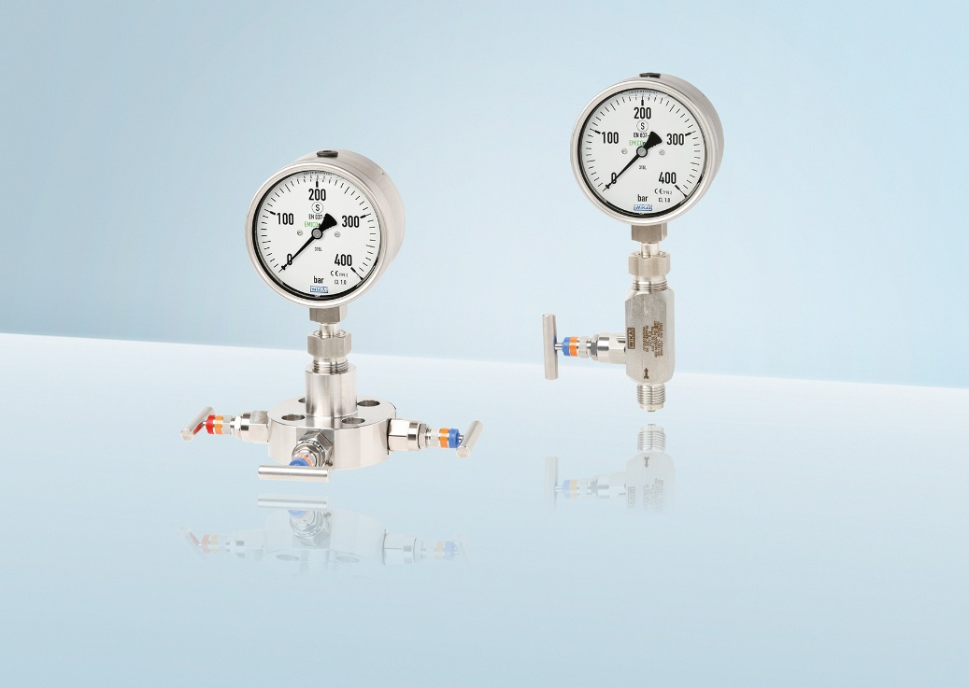
EMICOgauge pressure measuring system

Edited by:
WIKA Alexander Wiegand SE & Co. KG
André Habel Nunes
Marketing Services
Alexander-Wiegand-Straße 30
63911 Klingenberg/Germany
Tel. +49 9372 132-8010
Fax +49 9372 132-8008010
andre.habel-nunes@wika.com
www.wika.de

WIKA press release

